BOTL Convertor user guide

Generate Templates

**The feature aims to allow users to generate any non-travel related templates from the reference BOTLAID report. BOTLAID report can be generated using Batch Managers in System 6 Renovation.**

1. Go **Developer** -> **Macros**

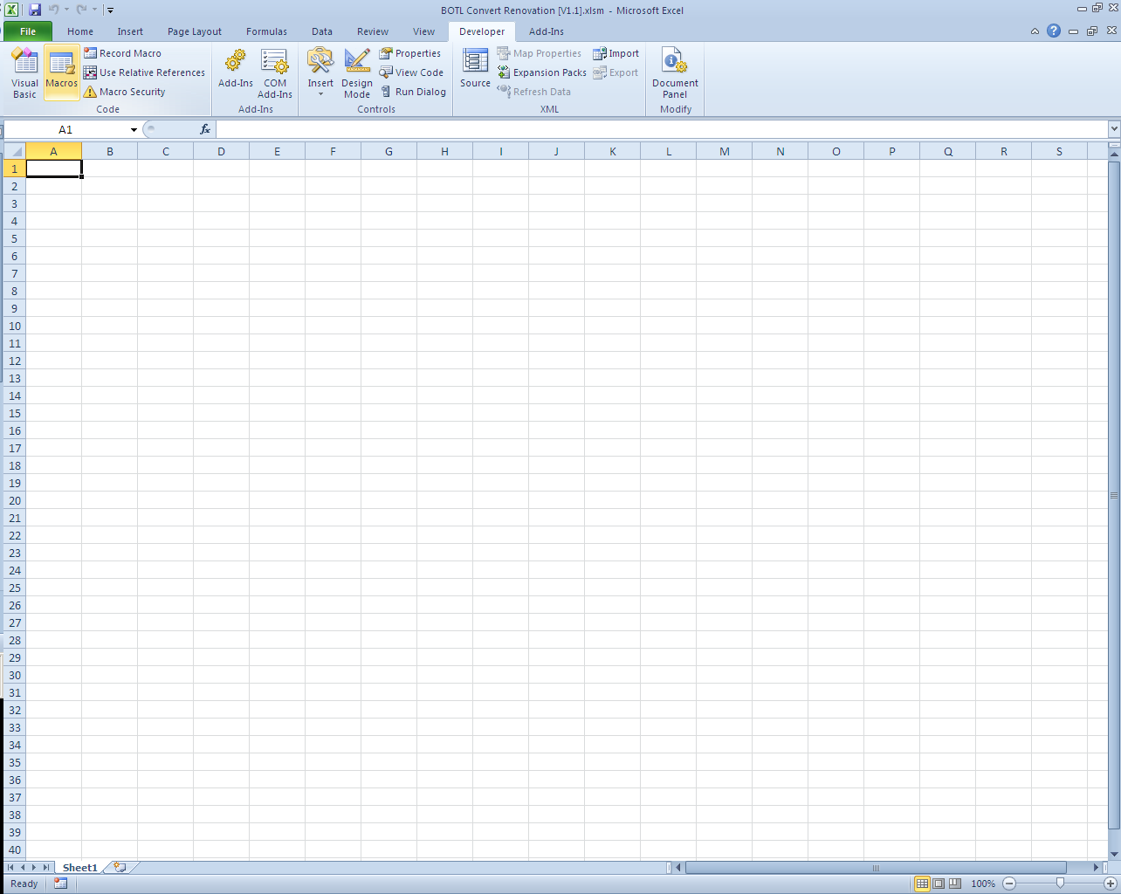

1. Select the macro with the name ***……!Generate_Template.Generate_Template***, and then click **Run**.

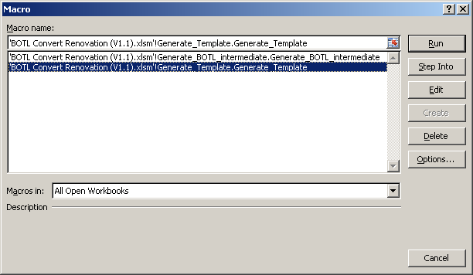

1. Select the reference BOTLAID file with the campaign code.

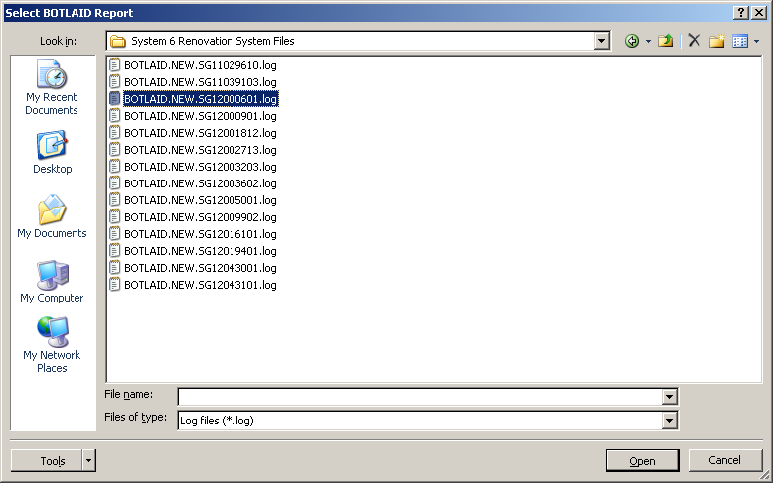

1. If the campaign allows dependent, the screen below will appear. Key in the **maximum number of dependent that is allowed** for this campaign. The number is determined by the users/ department.

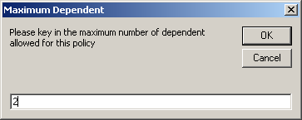

1. The templates will be generated. When the templates have been generated, a box with the word ***Template generated.*** will pop up.

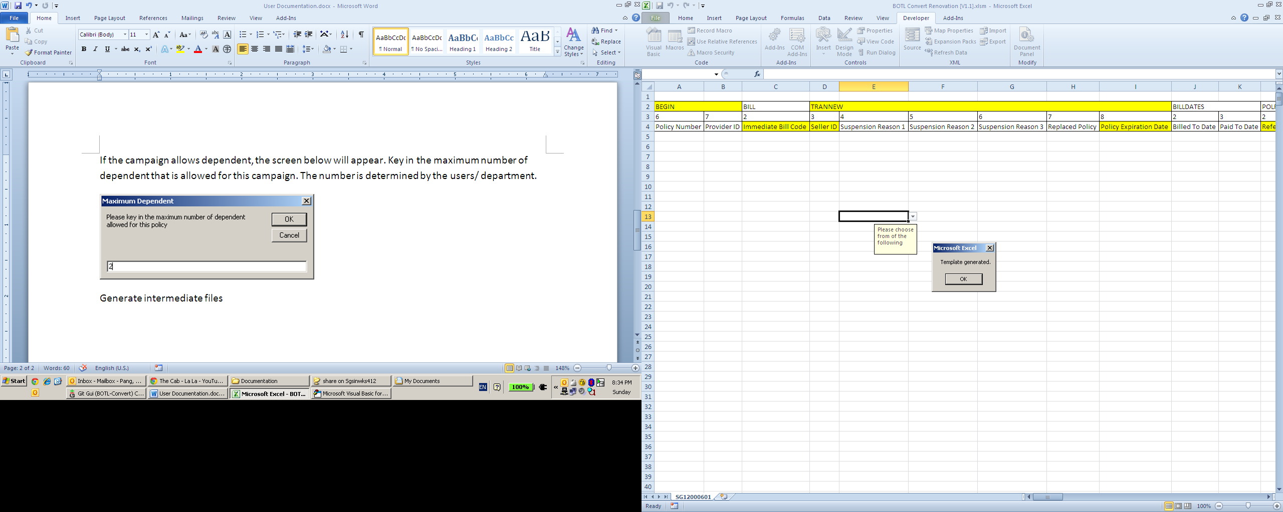

Note on filling up the templates:

* Address reference is used for multiple people to share the same address. You will only need to fill in that segment if the address you are entering is the same as one of the address you had entered before. In that case, you are not supposed to key in the ADDRESS and ADDRTYPE segment anymore.

Explanation of compulsory segment and compulsory segment:

|  |  |  |
| --- | --- | --- |
| Colour of Segment | Colour of Field | Remark |
| Yellow | White | Only fill up if necessary |
| Yellow | Yellow | Compulsory to fill up |
| White | White | Only fill up if necessary |
| White | Yellow | If there is no field in the segment, the field can be filled blank. If there is any field under the segment is filled, the field must be filled up too. Below is an example.    There is no need to fill anything and leave the address segment blank. However, if Address Line 3 is filled, Address Line 1 and Postal code must be filled up too. |

Generate BOTL intermediate files

**The feature aims to generate the BOTL intermediate files after the users enter the data and fill up the templates. The function required the same BOTLAID report file which is used to generate the templates to work.**

1. Open the **BOTL Convert Renovation.xlsm**.
2. Open the excel files with the completed data.
3. Go to **Developer** -> **Macros**



1. Select the macro with the name ***……!Generate_BOTL_intermediate.Generate_BOTL_intermediate***, and then click **Run**.

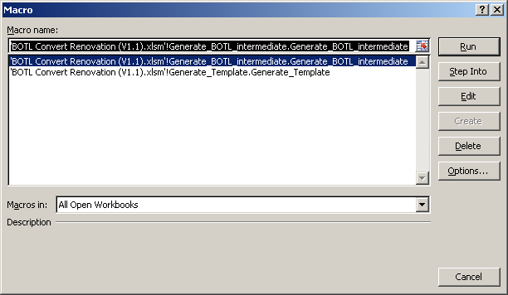

1. Select the **same reference BOTLAID** file that you have used to generate the template.



1. Navigate to the directory you want to save your output and enter a desired file name, then click on **Save**.

